COS 226 Algorithms and Data Structures Fall 2010

Midterm
This test has 8 questions worth a total of 60 points. You have 80 minutes. The exam is closed book, except that you are allowed to use a one page cheatsheet. No calculators or other electronic devices are permitted. Give your answers and show your work in the space provided. Write out and sign the Honor Code pledge before turning in the test.
“I pledge my honor that I have not violated the Honor Code during this examination.”
Problem | Score
0
1
2
3
Sub 1


Problem | Score
4
5
6
7
Sub 2

Name:
Login ID:
Precept: P01 11 Bob Tarjan P02 12:30 Yuri Pritykin P02A 12:30 Bob Tarjan P03 1:30 Aman Dhesi P03A 1:30 Siyu Yang
1
0. Miscellaneous. (2 point)
In the space provided on the front of the exam, write your name and Princeton NetID; circle your precept number; and sign the honor code.
1. Analysis of algorithms. (14 points)
(a) For each expression in the left column, give the best matching description from the right column.
−−−− | 1 + 2 + 4 + 8 + 16 + . . . + N | A. ∼ 1 2 N2 .
−−−− | 1 + 2 + 3 + 4 + 5 + . . . + N | B. O(N2).
 |  | C. Both A and B.
−−−− | 1 + 3 + 5 + 7 + 9 + . . . + N
 |  | D. Neither A nor B.
−−−− | 1 2 N2

1
−−−− N2 + 100N lg N
2
−−−− N2
−−−− N3
(b) For each quantity in the left column, give the best matching description from the right column.
−−−− Height of a weighted quick union data A. ∼ lg N in the best case. structure with N items.
B. ∼ lg N in the worst case. −−−− Height of a binary heap with N keys.
C. Both A and B.
D. Neither A nor B.
−−−− Height of a left-leaning red-black BST with N keys.
−−−− Maximum function-call stack size when (top-down) mergesorting N keys.
−−−− Maximum function-call stack size when quicksorting N keys.
−−−− Number of compares to binary search in a sorted array of size N.
(c) Consider the following code fragment.
int count = 0; int N = a.length; Arrays.sort(a); for (int i = 0; i < N; i++) {
for (int j = i+1; j < N; j++) { if (Arrays.binarySearch(a, a[i] + a[j])) count++; } }
Suppose that it takes 1 second when N =3, 500. Approximately how long will it take when N = 35, 000? Circle the best answer.
10 seconds 20 seconds 1 minute 2 minutes 1 hour 2 hours
(d) Consider the following Java data type deﬁnition for a 2-3 tree, where the nested class Node represents either a 2-node or a 3-node.
public class TwoThreeTree<Key extends Comparable<Key>, Value> { private Node root;
private class Node { private int count; private Key key1, key2; private Value value1, value2; private Node left, middle, right; } |  | // // // // | subtthe the the | ree one one two | couor or or | nt two two three | keys values subtrees
...
}

How much memory (in bytes) does each Node object consume? Circle your answer.
2. 8 sorting algorithms. (8 points) The column on the left is the original input of strings to be sorted; the column on the right
are the string in sorted order; the other columns are the contents at some intermediate step during one of the 8 sorting algorithms listed below. Match up each algorithm by writing its
number under the corresponding column. Use each number exactly once.
john aviv alan ctai andy aviv yort alan anna alan tzha azhu anna fyau alan azhu tzha andy fyau andy fyau ctai fyau john ddix ctai vyas anna ctai anna ctai ddix ctai tzha azhu ddix ravi aviv andy aviv nbal fyau andy azhu azhu fyau sida azhu ddix azhu ddix john ddix ddix anna john oleg azhu azhu azhu sguo kuan azhu nbal fyau kuan sguo ctai azhu ctai azhu nbal azhu sguo ctai nbal peck ddix aviv ddix aviv sguo aviv aviv john oleg ctai fyau alan fyau sida sida john kuan aviv sguo nbal john john john kuan tzha kuan sida kuan sida kuan kuan vyas kuan vyas vyas vyas vyas lily tzha lily kwak oleg kwak oleg kwak oleg kwak nbal vyas fyau oleg levy levy levy levy levy levy kwak levy levy levy kwak lily kwak muir kwak muir sguo kwak kwak vyas muir muir muir oleg muir oleg muir muir muir muir peck nbal peck peck peck alan oleg peck azhu peck ravi oleg ravi ravi ravi peck levy ravi aviv ravi kuan peck alan alan sida ravi sida alan alan sida yort ravi yort andy yort yort vyas yort john yort sida sguo azhu anna sguo andy peck azhu azhu nbal sguo sida andy azhu nbal anna ravi andy andy tzha nbal tzha anna lily tzha azhu tzha anna anna sguo lily vyas lily yort lily lily yort lily ddix lily tzha yort
0 1
(0) Original input
(1) Sorted
(2) Selection sort
(3) Insertion sort

(4) Shellsort (13-4-1 increments)
(5) Mergesort (top-down)
(6) Mergesort (bottom-up)

(7) Quicksort (standard, no shuﬄe)
(8) Quicksort (3-way, no shuﬄe)

(9) Heapsort
3. Binary heaps. (6 points) Consider the following binary tree representation of a max-heap.
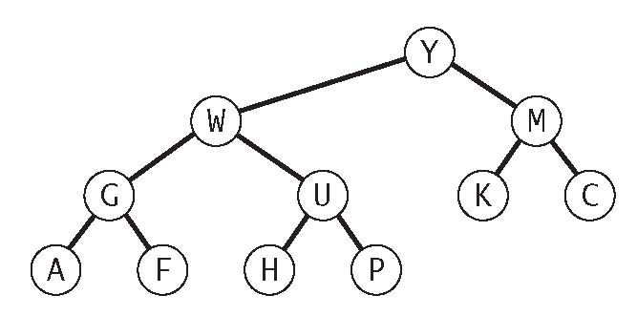
(a) Give the array representation of the heap.
(b) Delete the maximum key. Give the resulting heap, circling any entries that changed.
(c) Insert the key Q into the original binary heap. circling any entries that changed.

0 | 1 | 2 | 3 | 4 | 5 | 6 | 7 | 8 | 9 | 10 | 11 | 12
- |  |  |  |  |  |  |  |  |  |  |  | -

0 | 1 | 2 | 3 | 4 | 5 | 6 | 7 | 8 | 9 | 10 | 11 | 12
- |  |  |  |  |  |  |  |  |  |  | - | -

0 | 1 | 2 | 3 | 4 | 5 | 6 | 7 | 8 | 9 | 10 | 11 | 12
-

4. Red-black BSTs. (8 points) Consider the following left-leaning red-black BST.
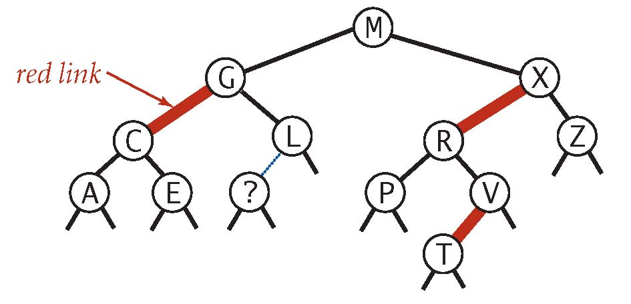
(a) Which one or more of the keys below could be in the node labeled with a question mark? ABCDEFGHIJKLMNOPQRSTUVWXYZ
(b) What is the color of the link from the node labeled with a question mark to its parent? Circle the best answer.

BLACK RED either RED or BLACK
(c) Add the key U and draw the resulting left-leaning red-black BST.
5. Hashing. (6 points) Suppose that the following keys are inserted in the order
ABCDEFG into an initially empty linear-probing hash table of size 7, using the following hash function:
key
A | 3
B | 1
C | 4
D | 1
E | 5
F | 2
G | 5

hash(key, 7)
What is the result of the linear-probing array?
Assume that the array size is ﬁxed and does not double.
0 | 1 | 2 | 3 | 4 | 5 | 6

6. Bitonic max. (8 points) An array is bitonic if it consists of a strictly increasing sequence of keys immediately followed
by a strictly decreasing sequence of keys. Design an algorithm that determines the maximum key in a bitonic array of size N in time proportional to log N.
(a) Give a crisp and concise English description of your algorithm—don’t write Java code. Your answer will be graded on correctness, eﬃciency, and clarity.
(b) To demonstrate your algorithm, list the ﬁrst four compares that your algorithm performs to ﬁnd the maximum key in the following bitonic array of 15 elements:
i | 0 | 1 | 2 | 3 | 4 | 5 | 6 | 7 | 8 | 9 | 10 | 11 | 12 | 13 | 14
a[i] | 10 | 34 | 56 | 76 | 87 | 80 | 70 | 66 | 56 | 30 | 28 | 25 | 20 | 15 | 11

7. Stable priority queue. (8 points) A min-based priority queue is stable if min() and deleteMin() return the minimum key that
was least-recently inserted. Describe how to implement a StableMinPQ data type such that every operation takes at most (amortized) logarithmic time.
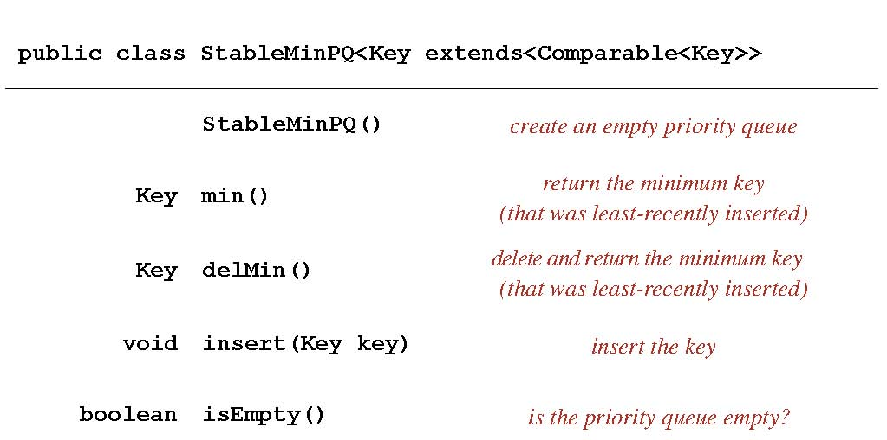
Give a crisp and concise English description of your algorithm—don’t write Java code. Your answer will be graded on correctness, eﬃciency, and clarity.

